CHAPTER THREE

METHODOLOGY

3.1 Introduction
The proposed method for generating AI-based educational videos in this study is based on an integrated architecture combining a knowledge graph, a retrieval-augmented generation (RAG) component, and a pedagogical constraint layer. These components were selected based on the literature reviewed and the limitations identified in existing AI-generated instructional videos, particularly their weak pedagogical structure, lack of organized prerequisite knowledge and tendency to produce inaccurate or fabricated content when relying solely on a language model’s internal knowledge.
The proposed pipeline involves five (5) states which include: construction of a knowledge graph from the uploaded course materials, indexing and retrieval of relevant content to ground generation in real source material, application of pedagogical constraints to structure each script segment, generation of narration audio from the constrained script, and generation of slides and assembly of the final instructional video.
3.2 research Design and Rationale
This study adopts a design science research (DSR) approach. The decision to use DSR is from the fact that the primary contribution of this research is not a theory tested through observaton alone, but a novel artifact whose value must be demonstrated through both its constructihon and its evaluation against defined criteria. The system itself changes across development phases as pedagogical constraints, retrieval strategies, and architectural choices are tuned in response to intermediate findings. The rationale for this choice is based on three considerations specific to the project’s objectives. First, the research problem is fundamentally constructive rather than explanatory, the study asks not only whether combining language models, retrieval augmented generation, and knowledge graphs under pedagogical ocnstraints improves educational video quality, but how such a system should be built to achieve that improvement. Secondly, the study requires a mechanism for grounding subjetive design decisions, for instance how a pedagogical constraint is weighted against a fluency or engagement objective, and finally, because the system is intended to generalize beyoind a single use case, DSR’s requirement of demonstrating utility, quality and efficacy through a repeatable evaluation process fits the study’s aim of producing a system whose effectiveness can be assessed independently of the researcher’s own judgement.

THEORETICAL CONSIDERATIONS

3.3.1 theoretical Basis for Retrieval Augmented Generation
The retrieval component of the pipeline was treated as an allocation problem, using inventory and resource allocation theory. standard top-k similarity retrieval risks a form of concentration synonymous to supplier dominance in inventory systems. When multiple sources describe the same concept, retrieval can be dominated by whichever source is most similar or best represented, at the expense of representational diversity. A source diversity aware retrieval strategy was adopted in this study to address this by relaxing the similarity threshold for underrepresented sources, ensuring a minimum allocation from each qualifying source while permitting proportionally greater allocation from sources already well represented.

standard top-k retrieval is unconstrained. For query embedding q and chunk embeddings c_i, similarity is cosine similarity:

sim(q, c_i) = (q · c_i) / (‖q‖ ‖c_i‖)

Standard top-k retrieval selects:

S = argmax_{S ⊆ C, |S|=k} Σ_{c_i ∈ S} sim(q, c_i)

Nothing prevents S from being dominated by one source j, if that source’s chunks happen to score highest in the similarity check. This is similar to a single supplier reliance problem, where you keep re-ordering from whoever quotes the lowest cost (highest similarity) per unit, with no minimum order diversity constraint. This approach is prom to systemic risk such as bias, blind spots and it contains a single point of failure.
The source diversity approach implements minimum allocation guarantee and proportional headroom for dominant sources
τ_j = τ₀ − α · max(0, q_min − n_j)

τ₀ = global similarity acceptance threshold
q_min = minimum chunks guaranteed per qualifying source (often 1)
n_j = chunks already accepted from source j so far in the selection pass
α = relaxation rate (tunable hyperparameter)

A chunk from source j is accepted once sim(q, c_i) ≥ τ_j. Under-quota sources get a lowered bar; once a source hits q_min, τ_j returns to τ₀, so it competes normally rather than being artificially boosted further

3.3.2 Theoretical Basis for Knowledge Graph Construction
The knowledge graph component was treated as a network optimization problem. Representing concepts as nodes and prerequisite relationships as directed edges allowed established graph algorithms to determine valid instructional sequences. Where sequencing must additionally account for estimated time or complexity per concept, the critical path method was used to provide a basis for identifying the sequence of concepts that most directly constrains overall course completion time, informing how the knowledge graph structures concept dependencies for video generation
Knowledge graph as a directed graph problem represents the graph as G = (V,E) where
V = {v₁, ..., v_n}, each v_i a concept node
E ⊆ V × V, directed edges where (v_i, v_j) ∈ E means v_i is a prerequisite of v_j
For instructional sequencing to be well-defined however, G must be a directed acyclic graph (DAG). a cycle would mean a concept prerequisites itself, which is instructionally incoherent. To avoid this, the system was designed to use a cycle-detection pass via depth first search (DFS) back-edge detection as part of the pipeline validation. Each node v_i was also assigned a natural duration d_i (estimated instructional time or complexity weight) which was used to determine the critical path.

- Earliest Start: ES(v_i) = max over predecessors p of {EF(p)}, with ES = 0 for source nodes
- Earliest Finish: EF(v_i) = ES(v_i) + d_I
- Latest Finish: LF(v_i) = min over successors s of {LS(s)}, with LF = EF(sink) for terminal nodes (computed backward from the end)
- Latest Start: LS(v_i) = LF(v_i) − d_I
- Slack (float): Slack(v_i) = LS(v_i) − ES(v_i)

The critical path is the set of nodes whsere slack (v_i) = 0 - the longest path through the DAG by cumulative duration..
CriticalPath = argmax over all root-to-sink paths P of Σ_{v_i ∈ P} d_I
Total course completion duration = EF(sink node) along the critical path.this results to a principal answer to “which concepts most directly determine overall course length

3.3.3 Theoretical Basis for the Pedagogical Constraints Layer
The pedagogical constraints layer was grounded in constrained optimization theory, with pedagogical rules formalized as hard or soft constraints on a content-quality objective function where multiple pedagogical objectives conflict, multi-criteria decision analysis was used to provide the basis for weighting competing criteria. The substantive content of density and pacing-related constraints was further grounded in cognitive load theory drawn from human factors and ergonomics. Some of the constraints used are:
- Prerequisite precedence: enforced by _topo_sort (kahn’s algorithm, in-degree/queue based) in sequencing_engine.py _topo_sort(). This constraint mandates that a concept cannot be taught before anything it requires or IS_A. this is the g(x) ≤ 0 feasibility cut satisfied by the ordering itself, not checked after the fact
- Cycle handling: cycle handling was implemented as a soft constraint in sequencing_engine.py _topo_sort() to prevent the appending of a cycle in the KG as this on its own raises no error. This constraint verifies the directed acyclic graph (DAG) assumption before critical path method (CPM) runs.

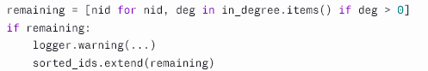

- Mastery exclusion: this constraint allowed for the removal of concepts already mastered by the learner by appending such concepts to the skipped array
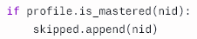
- Prerequisite-completeness repair: This served as a constraint-repair mechanism, not just detection: if a gap is found, the missing prerequisite is force-inserted at the front of the plan rather than merly logged, ensuring that no concept is taught with an unresolved prerequisite. Implemented in sequencing_engine.py _traverse(), this constraint was enforced by mutation (instead of just flagging the violation, the code directly changes the data structure by editing the plan in place) to make the constraint true.
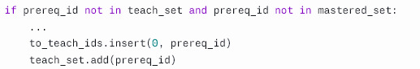
- RAG relevance floor: this constraint served to validate which chunks are even allowed to become candidates before any diversity logic or scoring runs. Implemented in _ground_concept() method in pedagogical_planner.py, the constraint verified a chunk’s distance (squared L2 Euclidean distance) from the concept being taught, removing chunks with a distance of over 1.5 from the content array.
- Diversity-qualification floor: in diversity_retrieval.py retrieve_diverse() , a source’s best chunk must clear this floor for that source to get a guaranteed slot in pass 1. for this constraint, similarity_floor was passed in as -distance_threshold (with a cutoff of 5), which filtered to ensure that every candidate reaching this function has already passed the floor
- Minimum-per-source guarantee: implemented in diversity_retrieval.py retrieve_diverse(), this constraint slices out the best available chunck from source for content selection, if set to two (2), it takes the top two chunks
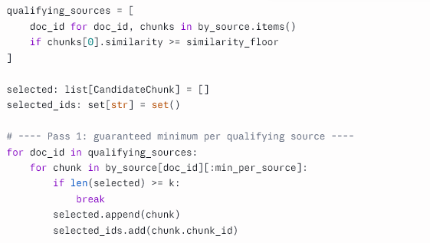
- Retrieval budget cap: implemented in sequencing enigne retrieve_diverse(), this constraint checked in both qualifying sources and chunks to ensure that total returned in either case never exceeds k regardless of how many sources qualify
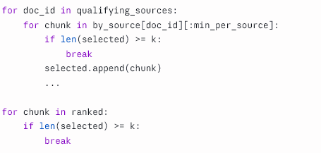
- Optional content exclusion: implemented in _personalise() in sequencing_engine.py, is a conditional hard constraint controlled by a drop_optional flag (exposed as a --drop-optional CLI argument, off by default). When enabled, any concept assigned an "optional" priority by the weighted-sum scoring constraint, meaning it is not a known mastery gap, does not lie on the CPM critical path, and scores below the optional threshold on goal relevance and ceiling fit, is excluded from the plan entirely via a continue statement, before it can reach RAG grounding or generation
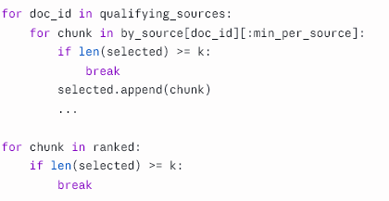
Both loops build selected by appending in whatever order what the loop is already iterating.
- Learner profile validity: This constraint was implemented in learner_profile _post_init(). it ensured that the moment any LearnerProfile object is constructed anywhere in the codebase, not just through the JSON loader, the two checks in it run immediately. If learning_style or depth isn't in the allowed set, a ValueError is raised and construction fails outright. No fallback, no default substitution, no logging-and-continuing was included, the object simply cannot exist in an invalid state.

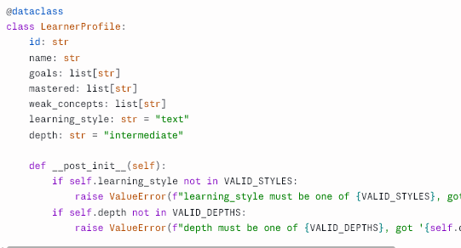

3.3.4 Theretical Basis for Architectural Design

Reliability engineering principles were employed for structuring interdependent components while lean process design (value stream mapping) was used for identifying and eliminating non-value adding steps in the content generation pipeline. Discrete event simulation was used to model the pipeline was as a sequence of interdependent processes, supporting architectural decisions aimed at minimizing delay andredundant computation between stages

To minimize delay and redundancy, discrete-event simulation was used as a means of modeling the pipeline as a sequence of interdependent processes, supporting architectural decisions aimed at minimizing delay and redundant computation between stages

3.4 System Architecture
The system was organised as a pipeline of connected stages, where the output of one stage becomes the input of the next. Course materials supplied by the user (lecture notes, textbooks, or slides on a given topic) form the starting point, and a finished instructional video is the final output. Figure 3.1 summarises the stages of the pipeline.
Figure 3.1: Stages of the AI video generation pipeline
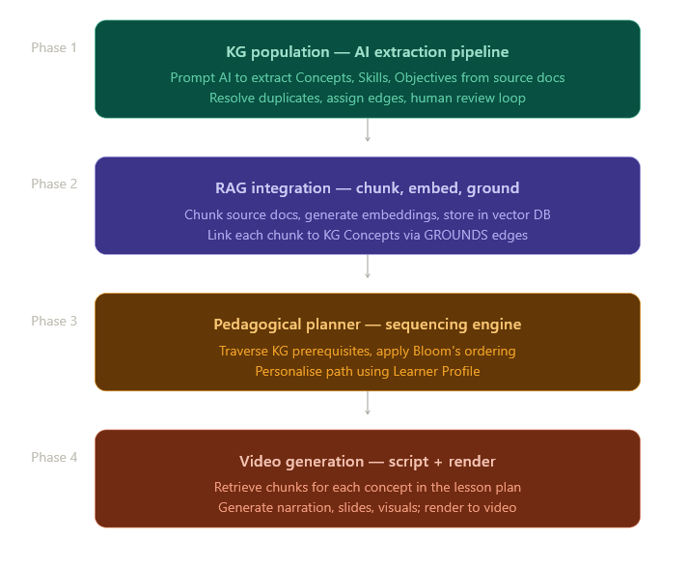
- Document ingestion – course materials are uploaded into the system.
- Knowledge graph construction – key concepts and their relationships are extracted from the documents and stored in a graph database.
- Content indexing for retrieval – the same documents are split into chunks and stored in a vector database for later retrieval.
- Retrieval-augmented content generation – relevant chunks are retrieved and combined with the knowledge graph structure to guide script generation.
- Pedagogical constraint application – scaffolding order, cognitive load limits, and instructional sequencing rules are applied to organise the generated script.
- Narration generation – the finalised script is converted into spoken narration.
- Slide generation and video assembly – visuals are produced for each script segment and combined with the narration into a single video file.
Each stage is implemented as an independent Python function, so that the documents can move through the pipeline step by step and any stage can be modified, re-run, or tested on its own without affecting the others.

3.4 Development tools and technologies
Table 3.1 summarises the main tools and technologies used to implement the system.
Table 3.1. Development tools and technologies
Component | Tool / Technology | Purpose
Programming language | Python | Implementation of the entire pipeline
Language model | GPT (OpenAI large language model) | Concept extraction, content generation, and script writing
Knowledge graph storage | Neo4j | Storing extracted concepts and their relationships
Vector database | Chroma | Storing document embeddings for retrieval-augmented generation
Text-to-speech | GPT-based text-to-speech | Converting the generated script into narration audio
Video assembly | MoviePy | Stitching slides and narration into a final video file
Development environment | Standard workstation with internet access | Running the pipeline and connecting to the language model API

3.5 System implementation
This section describes how each stage of the pipeline shown in Figure 3.1 was implemented. The code listings below are simplified extracts included to illustrate the logic of each stage rather than the complete source code of the system.

3.5.1 Knowledge graph construction
The knowledge graph module accepted the uploaded course documents and passed them to the GPT model with instructions to identify the key concepts discussed in the text and the relationships connecting them, such as prerequisite-of, part-of, or leads-to. The model returned these as concept-relationship-concept triples, which were then written into a Neo4j graph database using the Neo4j Python driver. Listing 3.1 shows a simplified version of this function.
Formally, the extracted concepts and their prerequisite relationships were treated as a directed graph
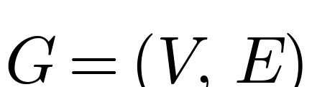 | (3.1)
where V is the set of concepts extracted from the course materials and E ⊆ V × V is the set of prerequisite relationships between them. Because a segment could only be generated for a concept once its prerequisites had been covered, the order in which concepts were presented followed a topological ordering π of G, such that
(3.2)
for every prerequisite edge (a, b) ∈ E. This ordering constraint is what allowed the pedagogical constraint module (Section 3.5.3) to enforce scaffolding, so that a concept was never introduced before the concepts it depended on.
Listing 3.1.: Knowledge graph extraction and storage (simplified)
def extract_knowledge_graph(document_text):
"""Send course text to GPT and return a list of
(concept, relationship, concept) triples."""
prompt = build_extraction_prompt(document_text)
response = call_gpt(prompt)
triples = parse_triples(response)
return triples

def store_triples_in_neo4j(triples, driver):
with driver.session() as session:
for subject, relation, obj in triples:
session.run(
"MERGE (a:Concept {name: $subject}) "
"MERGE (b:Concept {name: $object}) "
"MERGE (a)-[r:RELATION {type: $relation}]->(b)",
subject=subject, object=obj, relation=relation
)

3.5.2 Content indexing and retrieval (RAG)
To reduce the risk of the language model generating inaccurate or fabricated information, commonly referred to as hallucination, the system did not rely solely on the language model's internal knowledge. The uploaded documents were split into smaller text chunks, converted into vector embeddings, and stored in a Chroma vector database. When content needed to be generated for a particular concept, the system retrieved the most relevant chunks from Chroma using similarity search and supplied them to the GPT model as supporting context. Listing 3.2 shows this retrieval step.
Relevance between a query and a stored chunk was measured using cosine similarity between their embedding vectors:
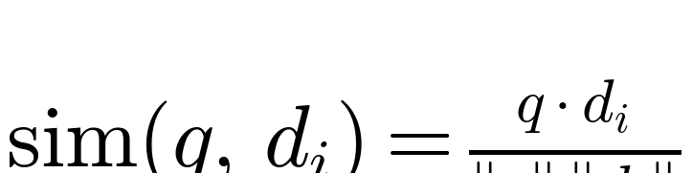 | (3.3)
where q is the embedding of the query and dᵢ is the embedding of a candidate chunk in the Chroma collection D. For each query, the top_k=4 highest-scoring chunks were retrieved and supplied to the language model as supporting context:
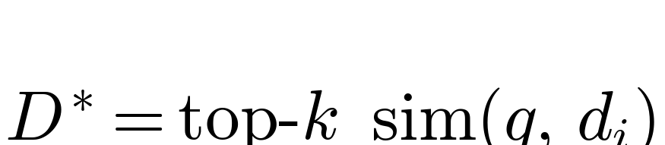 | (3.4)
Restricting generation to this retrieved set, rather than the language model’s unconstrained output, is what reduced the risk of hallucinated content described above. When Minimum-per-source guarantee was set to greater than 0,
Listing 3.2.: Document indexing and retrieval for RAG (simplified)
def index_documents(documents, chroma_collection):
for doc_id, text in enumerate(documents):
chunks = split_into_chunks(text, max_tokens=300)
embeddings = embed_chunks(chunks)
chroma_collection.add(
ids=[f"{doc_id}-{i}" for i in range(len(chunks))],
documents=chunks,
embeddings=embeddings
)

def retrieve_relevant_context(query, chroma_collection, top_k=4):
results = chroma_collection.query(
query_texts=[query],
n_results=top_k
)
return results["documents"][0]

3.5.3 Pedagogical constraint application
The pedagogical constraint module was responsible for shaping the retrieved content into a form that supports learning rather than simply presenting information. The prerequisite ordering obtained from the knowledge graph was used to arrange concepts from simple to complex (scaffolding), each script segment was limited to a small number of new ideas (cognitive load theory), and every segment was required to follow a consistent structure of recap, new concept, example, and check for understanding (instructional sequencing). Listing 3.3 shows how these rules were combined into the prompt used to generate each segment.
Cognitive load theory was operationalised as a hard limit on the number of new concepts Cₛ introduced within a single script segment s:
(3.5)
with N_max set to one in the prompt template shown in Listing 3.3, so that each segment introduced exactly one new concept alongside a recap of the prerequisite concept, an example, and a check for understanding.
Listing 3.3.: Pedagogically constrained prompt template (simplified)
def build_segment_prompt(concept, retrieved_context, previous_concept):
return f"""
Write one short instructional video segment for the concept
below, using ONLY the supporting context provided.

Concept to teach: {concept}
Previously covered concept: {previous_concept}
Supporting context: {retrieved_context}

Follow this structure:
1. Brief recap of "{previous_concept}"
2. Introduce "{concept}" in simple terms
3. Give one short worked example
4. End with a one-line check-for-understanding question

Keep the segment focused on a single new idea only.
"""

3.5.4 Narration generation
Once a segment's script had passed through the pedagogical constraint module, it was sent to a GPT-based text-to-speech process to generate the narration audio for that segment. Listing 3.4 shows this step.
Listing 3.4.: Narration audio generation (simplified)
def generate_narration(script_segment, output_path):
audio = gpt_text_to_speech(text=script_segment, voice="default")
with open(output_path, "wb") as f:
f.write(audio)
return output_path

3.5.5 Slide generation and video assembly
A slide was generated for each script segment to visually support the narration. MoviePy was then used to combine each slide with its matching narration audio clip, add simple transitions between segments, and render the sequence into a single instructional video file. Listing 3.5 shows a simplified version of the assembly step.
Listing 3.5.: Slide and narration assembly into a video (simplified)
from moviepy.editor import ImageClip, AudioFileClip, concatenate_videoclips

def assemble_video(slide_paths, audio_paths, output_path):
clips = []
for slide_path, audio_path in zip(slide_paths, audio_paths):
audio_clip = AudioFileClip(audio_path)
image_clip = ImageClip(slide_path).set_duration(audio_clip.duration)
image_clip = image_clip.set_audio(audio_clip)
clips.append(image_clip)

final_video = concatenate_videoclips(clips, method="compose")
final_video.write_videofile(output_path, fps=24)
return output_path

3.6 Case study: Product Development (Industrial Engineering)
The system was applied to the topic of Product Development, drawn from an Industrial Engineering course, to demonstrate its use on a real subject area. Course materials on this topic were uploaded into the system, which then constructed a knowledge graph, indexed the materials for retrieval, applied the pedagogical constraints, and generated a complete instructional video covering the selected Product Development sub-topics. This subject area was chosen because it contains a sequence of interdependent concepts, making it suitable for testing whether the system's scaffolding and instructional sequencing features worked as intended.

3.7.2 Evaluation design
To address Objective 5 in Chapter One, the system was evaluated by comparing learner performance after exposure to two versions of instructional content covering the same Product Development sub-topics: the video generated by the proposed system, and an equivalent human-made instructional video.

3.7.3 Participants
Participants were students who had not previously studied the selected Product Development sub-topics in depth. They were divided into two groups: one group watched the AI-generated video, while the other watched the human-made video covering the same content.

3.7.4 Evaluation instrument
A short quiz was administered to both groups immediately after they finished watching their assigned video. The quiz questions were designed to test comprehension and retention of the concepts covered in the video, and the same quiz was given to both groups so that the results could be compared directly.

3.7.5 Data analysis procedure
Quiz scores from the two groups were compared to determine whether there was a meaningful difference in comprehension between learners who watched the AI-generated video and those who watched the human-made video. This comparison was intended to indicate whether the proposed system achieved instructional quality comparable to a human-made video. The results of this comparison are presented and discussed in Chapter Four.
This comparison was carried out using an independent-samples t-test between the mean quiz score of the group that watched the AI-generated video (AI) and the group that watched the human-made video (H):
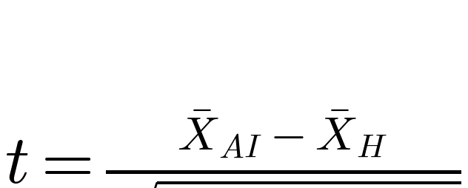 | (3.6)
where X̄_AI and X̄_H are the group mean scores, n_AI and n_H are the group sizes, and sₚ² is the pooled variance of the two groups:
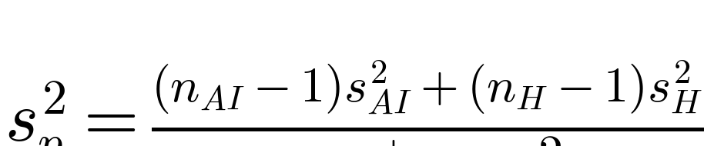 | (3.7)
The magnitude of any difference found was further reported using Cohen’s d effect size:
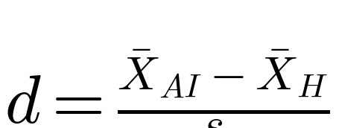 | (3.8)
A significance level of α = 0.05 was adopted, so that a difference between the two groups was considered statistically significant where p < 0.05.

